**Thread Practice programs**

1. Write a program to create a thread and find the sum of odd numbers from 1 to 100 in this thread. Find the sum of even numbers for the same range in the main thread. 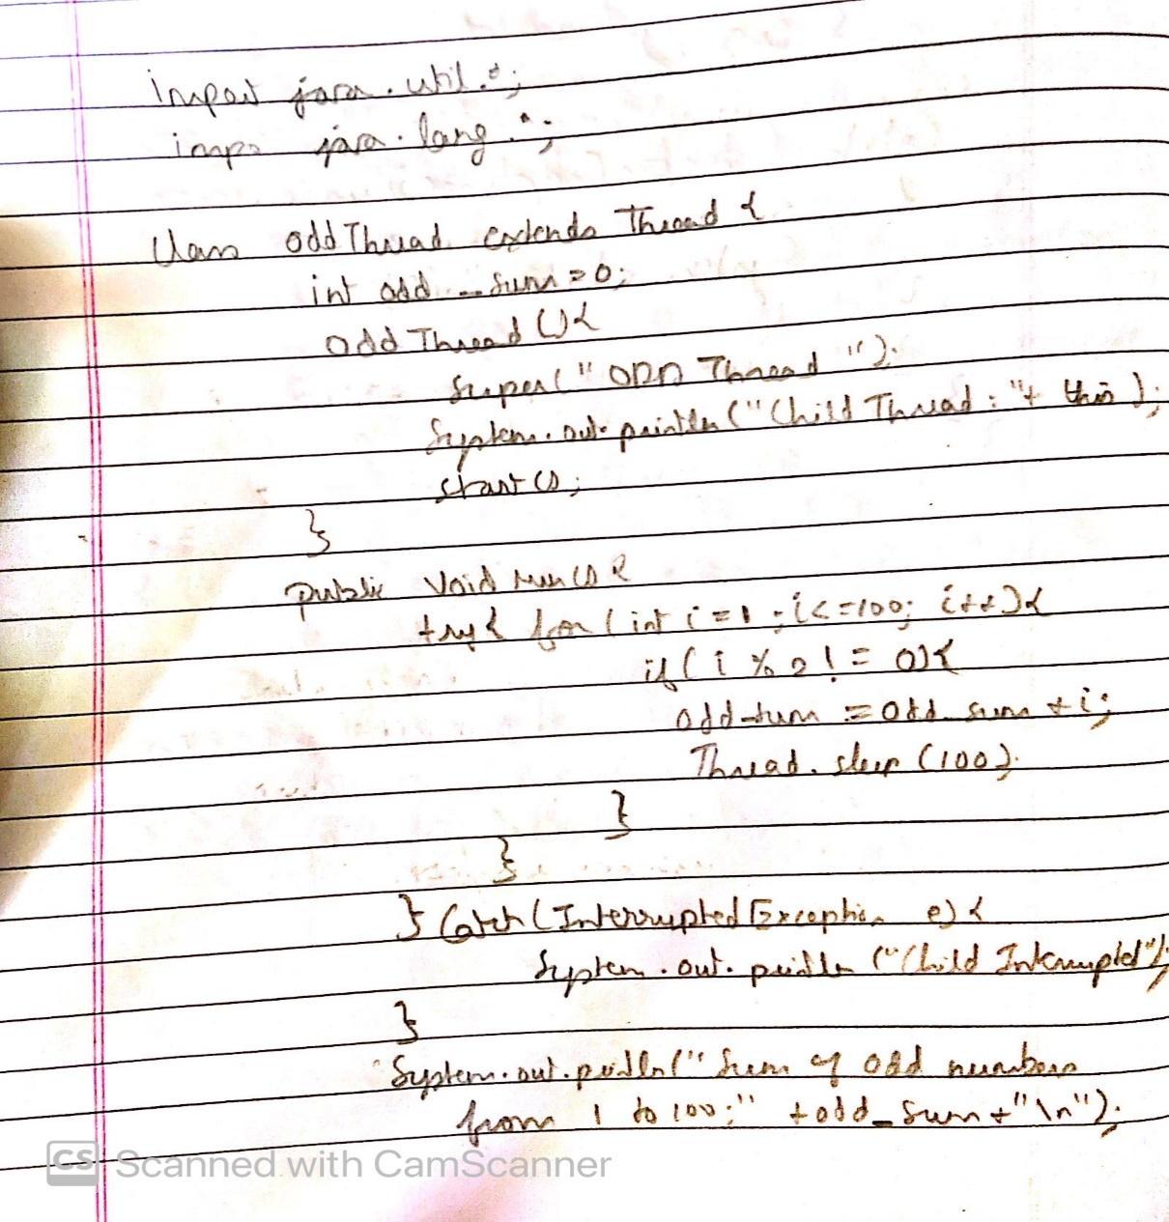

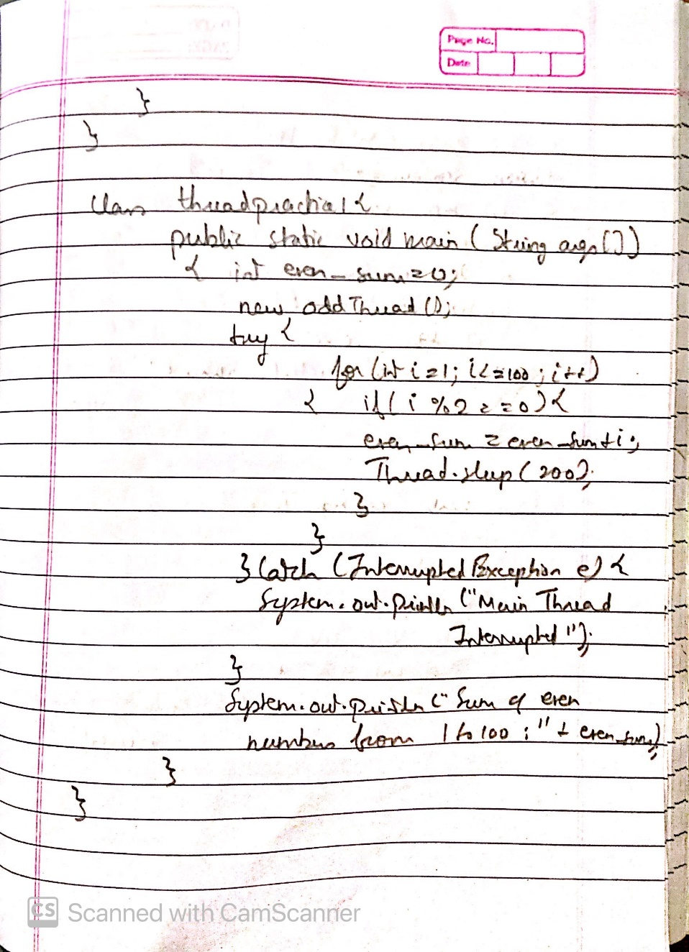

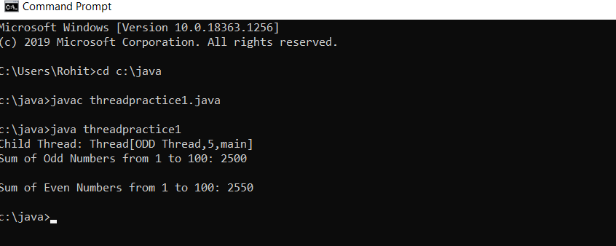

1. Develop a multithreaded Java program to create three threads. First thread generates  random integer for every second and if the value is even, second thread computes the  square of number and prints. If the value is odd, the third thread will print the value of  cube of number.

